SMART CONTACT MANAGER

A Mini project report
BACHELOR OF COMPUTER SCIENCE
(2024 – 2027)

Submitted by
JAYALAKSHMI.R THRISHA.S 222408420 222408440

DHARSHINI.G SRINITHI.V
222408413 222408437

Under the Guidance of
Mrs. V. THILAGAVATHY M.Sc., M.Phil.
Assistant Professor
Department of Computer Science

SOKA IKEDA COLLEGE OF ARTS AND SCIENCE FOR WOMEN,
MADHANANGKUPPAM, CHENNAI – 600 099.
Affiliated to the University of Madras, Chepauk, Chennai 600 005.
ABSTRACT
The Contact Manager is a software application designed to store, organize, and manage personal or professional contact information efficiently. In daily life, people interact with many individuals and maintaining their contact details manually can be difficult and time-consuming. This project provides a digital solution to manage contact information in a structured and user-friendly manner.
The system allows users to add, view, update, search, and delete contact details such as name, phone number, email address, and other relevant information. It helps users quickly access required contact details without searching through physical records or scattered data. The application ensures better organization and reduces the risk of losing important contact information.
The Contact Manager improves productivity by providing a simple interface and efficient data handling. It can be implemented using programming languages and database systems to securely store and retrieve contact data. This project demonstrates the practical use of data management concepts and user interface design in developing a useful real-world application.
Overall, the Contact Manager system provides a reliable and convenient way to maintain and manage contact information digitally.

CHAPTERS | TITLE | PAGE NO
 | INTRODUCTION | 4
 | PROJECT OVERVIEW | 4
 | PROJECT INSTRUCTIONS | 5
 | PRE-REGUISITES | 6
 | PROJECT THUMBNAIL | 7
 | PROJECT ARCHITECTURE | 8
 | TECHNICIAL ARCHITECTURE | 9
 | ER DIAGRAM | 10
 | FEATURES | 10
 | ROLES AND RESPONSIBILITY | 11
 | USER FLOW | 12
 | PROJECT SETUP AND CONFIGURATION | 12
 | BACKEND DEVELOPMENT | 13
 | DATABASE CONFIGURATION AND SETUP | 15
15. | PROJECT EXECUTION | 16

1.INTRODUCTION
The Contact Manager is a software application used to store and manage contact information in a digital format. It helps users organize details such as names, phone numbers, and email addresses in one place. The system makes it easy to add, search, update, and delete contact records, allowing users to access their contact information quickly and efficiently.

2.PROJECT OVERVIEW
The Contact Manager is an application used to store and manage contact details such as name, phone number, and email. It allows users to add, view, update, search, and delete contacts easily, helping organize and access contact information efficiently.

KEY OBJECTIVES
- To store and manage contact information efficiently.
- To allow users to add, update, search, and delete contacts.
- To organize contact details in a simple digital system.
- To provide quick and easy access to stored contact information.

TARGET USERS
- Individuals who want to store and manage personal contacts.
- Students who need to organize friends and academic contacts.
- Small business owners managing customer contact details.
- Office staff handling professional contact information.

3.PROJECT INSTRUCTION
The Contact Manager project is a software application designed to store, organize, and manage contact details in a digital format. It helps users maintain information such as names, phone numbers, and email addresses in an easy and efficient way. The system allows users to add, view, update, search, and delete contact records, making contact management simple and convenient.

1️⃣ Install Node.js (If Not Installed)

Download and install Node.js from: https://nodejs.org/

After installation, verify:
node -v
npm -v

2️⃣ Create a Backend Project Folder
• Choose or create a directory where you want your backend.
• Open your terminal or command prompt.
• Navigate to the selected directory:
cd your-project-folder
• Create a new backend folder:
mkdir server
cd server

3️⃣ Initialize Node Project
Run: npm init -y
This will create a package.json file.

4️⃣ Install Required Dependencies
Install Express:
npm install express
npm install mongoose
For development (auto-restart server):
npm install nodemon --save-dev

5️⃣ Create Basic Server File
Inside the server folder:
• Create a file called: server.js

6️⃣ Enable ES Modules (Important)
Open package.json and add: "type": "module"

7️⃣ Start the Backend Server
Run: npm run dev
OR if not using nodemon: node server.js

8️⃣ Open in Browser
Open: http://localhost:5000
You should see: Backend is running

4.PRE-REQUISITES
The pre-requisites for the Contact Manager project include basic knowledge of programming, database management, and a computer system with the required software installed. Tools such as a programming language, development environment, and database system are needed to design, develop, and run the application successfully.

Software Requirements
Software | Purpose
Node.js | JavaScript runtime for backend
MongoDB | NoSQL database for data storage
npm | Package manager
Git | Version control system
Code Editor | VS Code, WebStorm, or similar
Knowledge Requirements
• JavaScript ES6+ syntax and concepts
• Node.js and Express.js for RESTful API development
• MongoDB and Mongoose ODM
• JWT authentication and bcrypt password hashing
• Git version control workflow

5.PROJECT THUMBNAIL
A Project Thumbnail is a brief summary or snapshot of the project that gives an overview of its purpose, functionality, and key features in a concise format. For the Contact Manager, it highlights that the system is designed to store, organize, and manage contact details digitally, allowing users to add, view, update, search, and delete contacts efficiently. It provides a quick understanding of the project at a glance.


6.PROJECT ARCHITECTURE
Project Architecture refers to the structured design and layout of the Contact Manager system, showing how different components interact to perform tasks efficiently. It defines the arrangement of the user interface, application logic, and database, ensuring smooth data flow and proper functioning. The architecture provides a blueprint for how contacts are added, stored, retrieved, updated, and deleted, making the system organized, maintainable, and scalable.

High-level architecture diagram illustrating the three-tier backend structure.
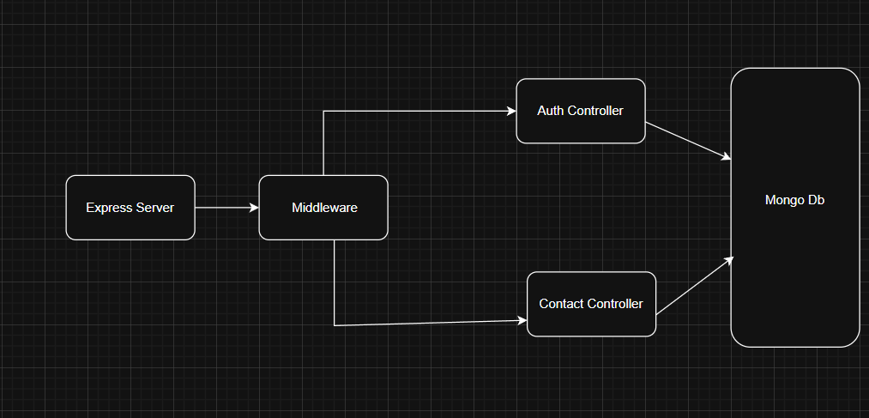
Node.js + Express Backend
• RESTful API architecture
• JWT authentication middleware
• MVC pattern (Models, Controllers, Routes)
• Input validation and error handling

MongoDB Database
• Document-based NoSQL storage
• Mongoose ODM for schema modeling
• Two collections: Users and Contacts
• Indexed fields for optimized queries

7.TECHNICAL ARCHITECTURE
Technical Architecture defines the detailed design of the Contact Manager system, specifying the technologies, software, and frameworks used to build the application. It shows how the user interface, application logic, and database interact, and outlines the technical components, data flow, and system infrastructure required for implementation. This ensures the system is reliable, scalable, and maintainable from a technical perspective.

Backend Architecture (Node.js + Express)
• Controllers: Business logic for authentication and CRUD operations
• Models: Mongoose schemas defining data structure
• Routes: API endpoint definitions with HTTP methods
• Middleware: JWT verification, error handling, validation
• Configuration: Database connection and environment variables

Database Architecture (MongoDB)
• Users Collection: _id, name, email, password (hashed), timestamps
• Contacts Collection: _id, userId (FK), name, email, phone, notes, tags[], timestamps
• Relationships: Many-to-One (Contacts → User)
• Indexes: email (unique), userId, name, tags (for search)

8.ER DIAGRAM
An ER (Entity-Relationship) Diagram is a visual representation of the data structure of a system. In the Contact Manager project, it shows how different entities—such as Contacts, Users, and Groups—are related to each other. The diagram defines entities, their attributes (like name, phone number, email), and the relationships between them, helping in designing the database efficiently and ensuring proper data organization.

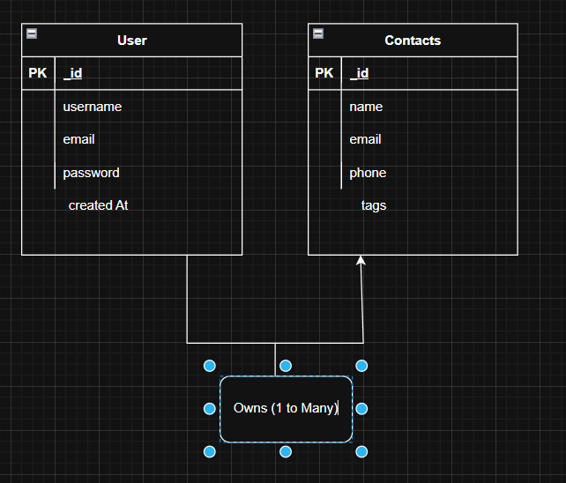

9.FEATURES
Features are the key functionalities and capabilities provided by a system to meet user requirements. In the Contact Manager project, features refer to the main operations the application offers, such as adding new contacts, viewing existing contacts, updating contact details, searching for specific contacts, and deleting unwanted records. Features define what the system can do to make contact management efficient and user-friendly.

Core Features

# | Feature | Description
1 | User Authentication | JWT-based registration, login, and session management with bcrypt password hashing
2 | Contact CRUD | Create, read, update, and delete contacts with full validation and error handling
3 | Tag Categorization | Organize contacts with multiple tags (Work, Family, Friends, etc.) and filter by category
4 | Real-time Search | Debounced search across name, email, and tags with instant results

10.ROLES AND RESPONSIBILITY
Roles and Responsibilities define the specific duties assigned to individuals or components involved in a project. In the Contact Manager project, this includes the responsibilities of users and the system, such as:
- User Role: Add, view, update, search, and delete contacts.
- System Role: Store data securely, process user requests, and provide accurate information.
USER:
Registration - Register on the application using the name, email , password
- Login - Login on the application using the email and registered password
- Search - Search for a contact using name , email or tags
- Add Contact - Add new contact - name , email , phone , notes , tags
- Edit Contact - Edit the existing contact
- Delete Contact - Delete any contact

11.USER FLOW

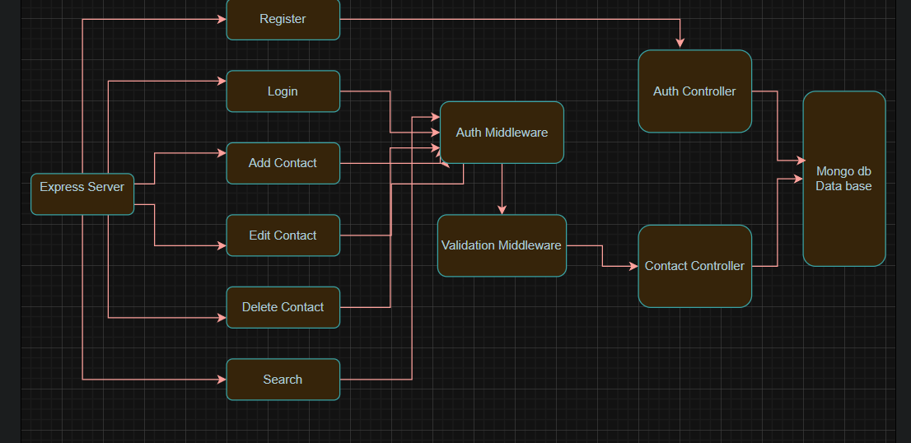

12.PROJECT SETUP AND CONFIGURATION
Project Setup and Configuration refers to the process of preparing the environment and tools required to develop and run the Contact Manager system. It includes installing software, setting up the database, configuring development tools, and organizing project files. Proper setup ensures that the application can be built, tested, and executed smoothly without errors.

Folder Structure

project Setup

1. Install required tools and software:
• Node.js.
• MongoDB.
2. Create project folders and files:
• Server folders.
3. Install Packages:
Backend npm Packages
• Express.
• Mongoose.
• Cors.

13.BACKEND DEVELOPMENT
Backend Development refers to the part of the Contact Manager project that handles the server-side logic, database interactions, and core functionality of the system. It manages tasks such as storing, retrieving, updating, and deleting contact information, processing user requests, and ensuring secure and efficient data management. The backend operates behind the scenes to support the user interface and overall application performance.
• Setup express server
• Create index.js file in the server (backend folder).
• Create a .env file and define port number to access it globally.
• Configure the server by adding cors, body-parser.
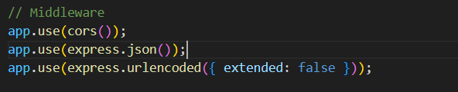
• User Authentication:
• Create routes and middleware for user registration, login, and
• Set up authentication middleware to protect routes that require user authentication.
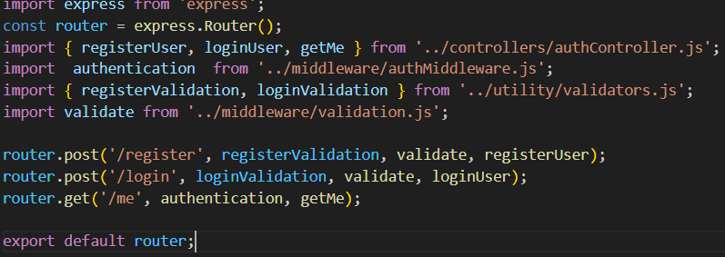
• Define API Routes:
• Create separate route files for different API functionalities such as user authentication and crud operation for contacts
• Implement route handlers using Express.js to handle requests and interact with the database.
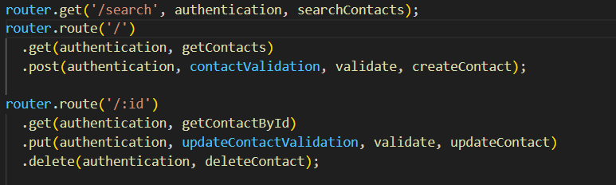
• Implement Data Models:
• Define Mongoose schemas for the different data entities like user and contact
• Create corresponding Mongoose models to interact with the MongoDB database.
•Implement CRUD operations (Create, Read, Update, Delete) for each model to perform database operations. 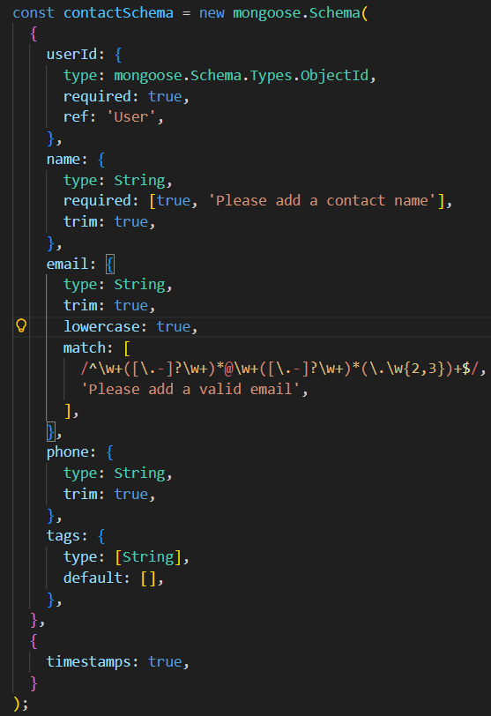
• Error Handling:
• Implement error handling middleware to catch and handle any errors that occur during the API requests.
• Return appropriate error responses with relevant error messages and HTTP status codes.
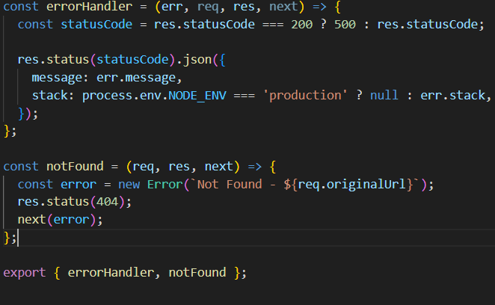

14. DATABASE CONFIGURATION AND SETUP
Database Configuration and Setup refers to the process of creating and preparing the database for the Contact Manager project. It involves designing the database structure, defining tables and fields (like contact name, phone number, email), setting up relationships between entities, and configuring access permissions. Proper setup ensures efficient data storage, retrieval, and management, enabling the application to function reliably.
1. Configure MongoDB:
• Install Mongoose.
• Create database connection.
• Create Schemas & Models.
2. Connect database to backend:
Now, make sure the database is connected before performing any of the actions through the backend. The connection code looks similar to the one provided below.
3. Configure Schema:
Firstly, configure the Schemas for MongoDB database, to store the data in such pattern. Use the data from the ER diagrams to create the schemas.
The schemas are looks like for the Application.
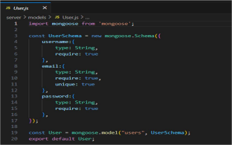

15.PROJECT EXECUTION
Project Execution refers to the phase in which the Contact Manager project is actively implemented and run. It involves deploying the application, performing operations such as adding, updating, searching, and deleting contacts, and ensuring that all features work as intended. This phase demonstrates the practical functionality of the system and verifies that it meets user requirements.
Execution Steps
- Open the project folder in the terminal
- Make sure you have a start script in the package.js file
- Use the command npm start to start the server
- You will the Running on PORT message on the successfully starting the server
- You will also see the database connected message if the database is connected successfully
- Use the Thunder client or Postman for using the created api’s

OUTPUT SCREENSHOTS

1.REGISTER API

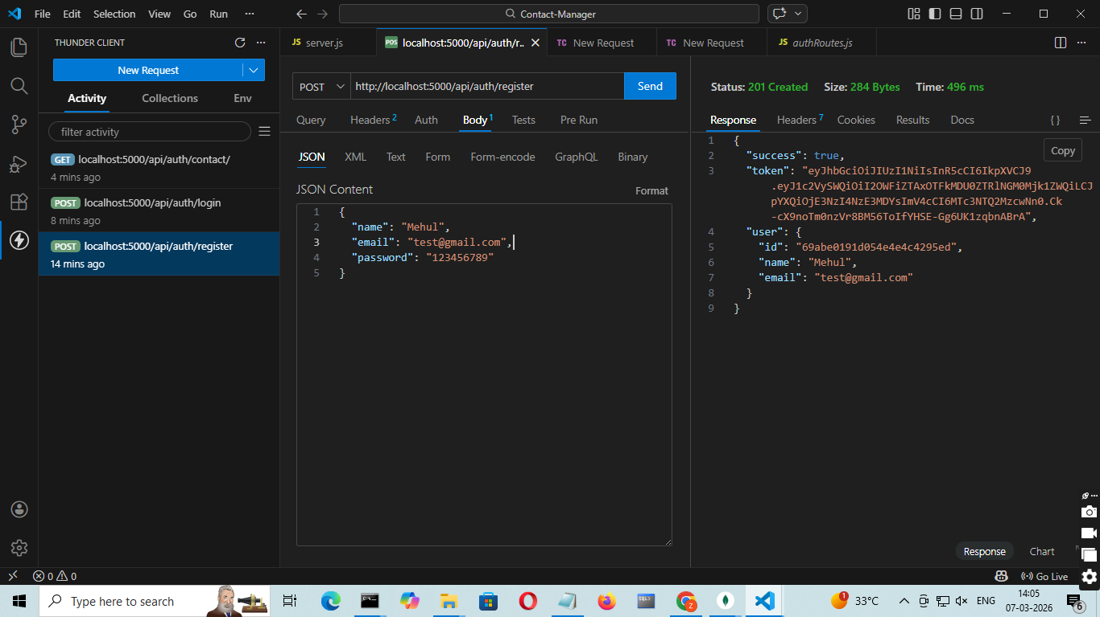

2.LOGIN API
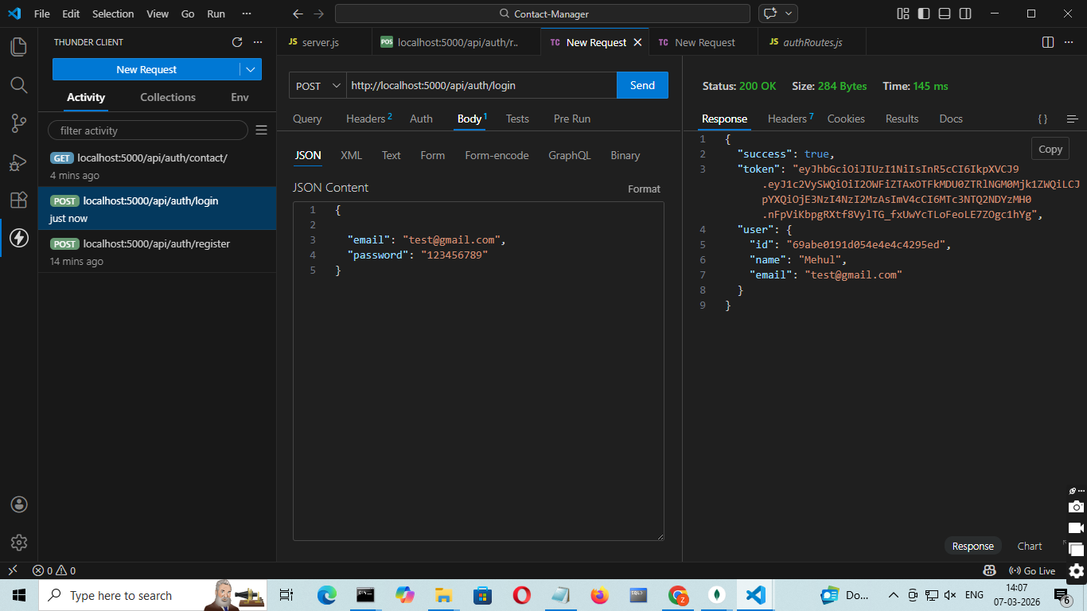
3.CREATE NEW CONTACT
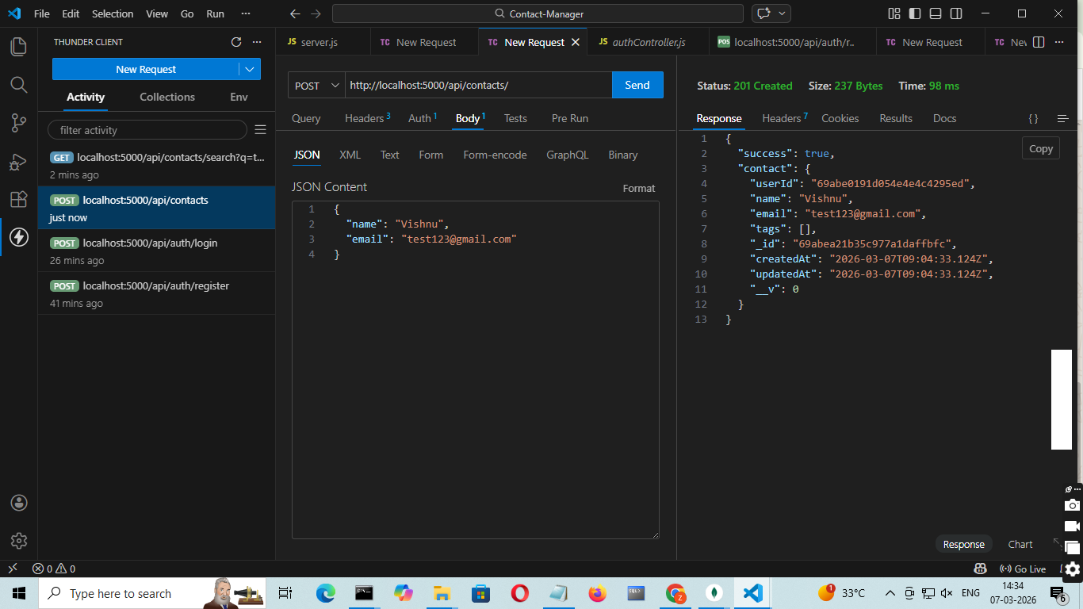

4.UPDATE CONTACT
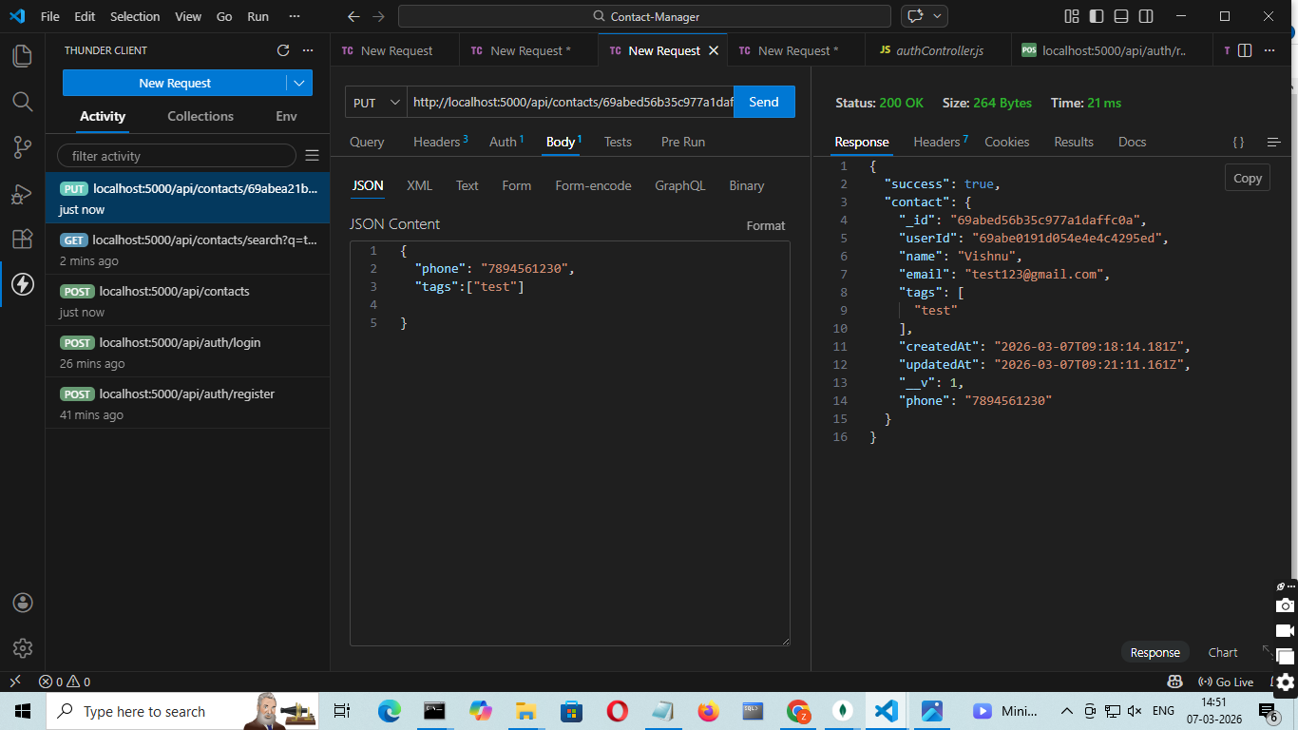
5.DELETE CONTACT
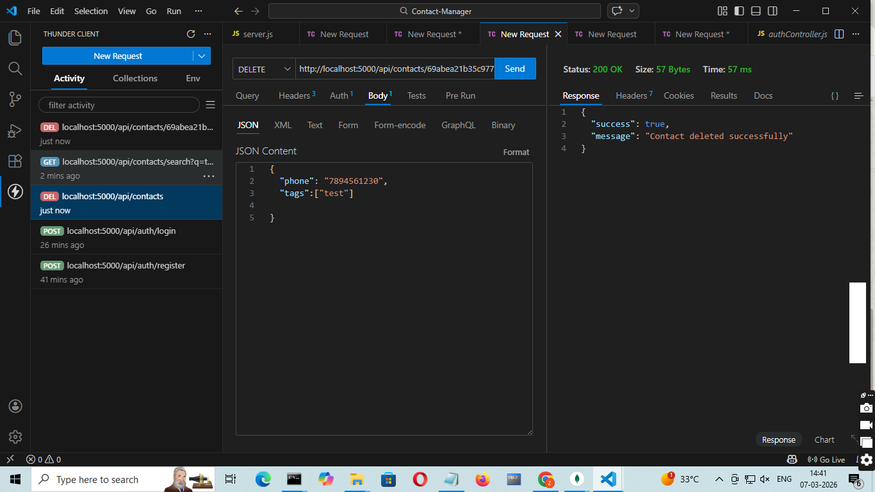

6.SEARCH CONTACT
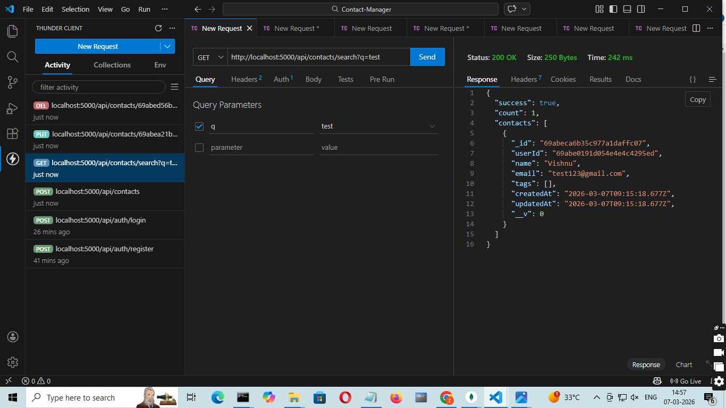
7.GET THE CURRENT USER
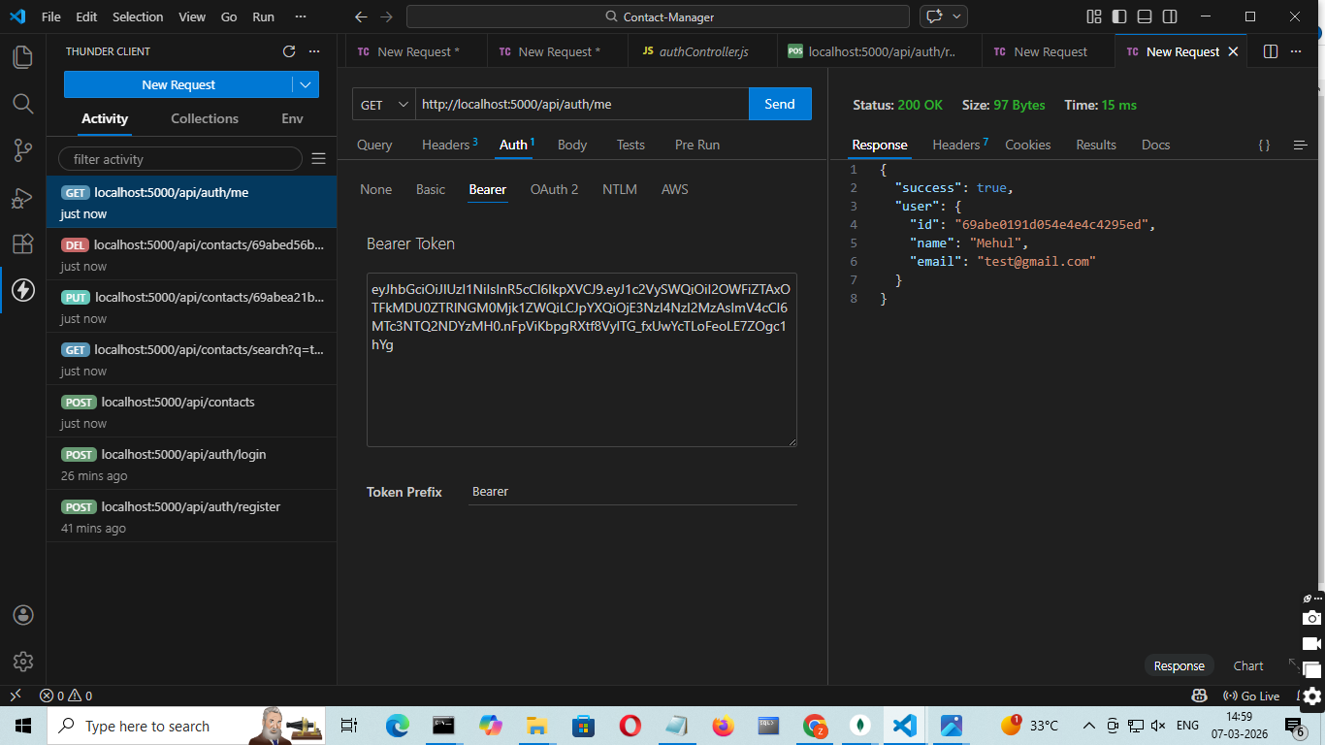

CONCLUSION:
The Contact Manager project helps users easily store, manage, and organize contact information. It allows adding, updating, searching, and deleting contacts efficiently. This system reduces manual work and makes contact management faster and more convenient. Overall, it is a useful tool for organizing personal or professional contacts.

